**Milestone 2**

**Group 3**

**Alshaykhah Alshammari**

|  |  |  |
| --- | --- | --- |
| **SID** | **STUDENT NAME** | **Effort given** |
| 202110519 | Maryam Bawazir | 25% |
| 202205676 | Hala Hamdoun | 25% |
| 202003441 | Alshaykhah Alshammari | 25% |
| 202109396 | Rogayah omar | 25% |

**CMPS310– B51**

**23, November 2024**

**L51**

**Task 1**

**Sequence diagram 1**

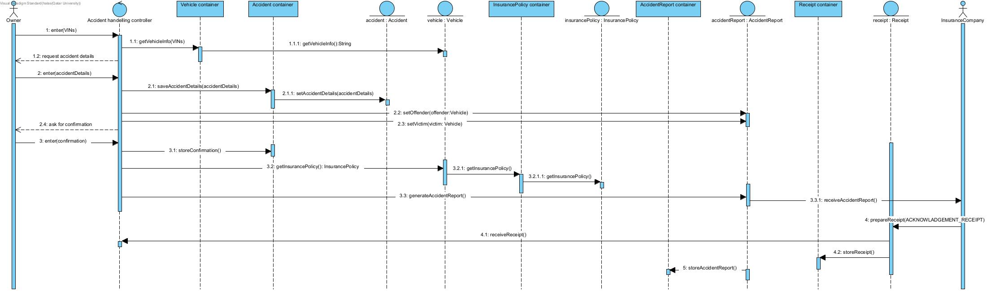

This sequence diagram is based on the following use case Handel Accident that we have created in milestone1.

|  |  |  |
| --- | --- | --- |
| **Use case Id:** UC03 | Handel accident | |
| **Brief Description** | Use case begins when the owner of the offending vehicle enters the VINs of both vehicles involved. The system retrieves vehicles registration details. The system creates an accident report which. The report is sent to the insurance company and the company sends back a receipt. | |
| **Primary actors** | Owner, Insurance company | |
| **Trigger** | The owner of the offending vehicle enters the VINs of both vehicles involved in the accident | |
| **Preconditions:**   1. **An accident happens between only two vehicles** 2. **The owner of the offending vehicle accepts responsibility for the accident** 3. **Both vehicles have a valid registration** | | |
| **Post-conditions:**   1. **An accident report was created** 2. **The insurance company of the offending vehicle was informed with the accident details** | | |
| **Main Success Scenario** | | |
| **Actor Action** | | **System Response** |
| 1. The offending vehicle owner enters the VINs of both vehicles involved in the accident | | 2.Retrieve vehicles registration info and other vehicle data |
|  | | 3.Request accident details |
| **4. The offending vehicle owner enters accident details** | | 5.Save accident information |
|  | | 6. Assign offending and victim vehicles |
|  | | 7. Request offending vehicle’s confirmation |
| **8. The offending vehicle owner sends a confirmation** | | 9. Store confirmation |
|  | | 10. Retrieve offending vehicle’s insurance policy |
|  | | 11. Generate an accident report |
|  | | 12. Provide the insurance company with the accident report |
| **13. The insurance company replies with an acknowledgement receipt** | | 14. Save receipt |
|  | | 15. Store accident report |

**Sequence diagram 2**

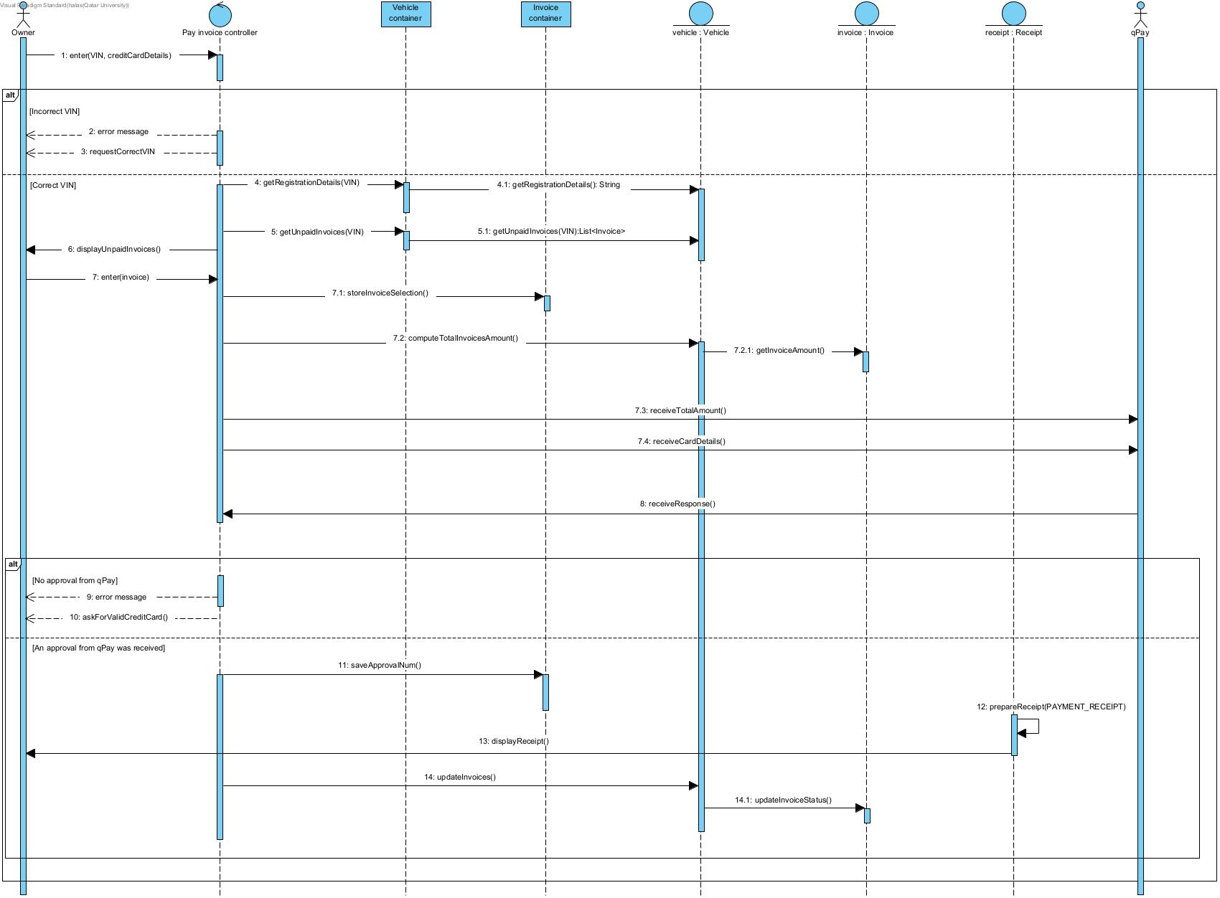

This sequence diagram is based on the following use case Pay Invoice that we have created in milestone1.

|  |  |  |
| --- | --- | --- |
| **Use case Id:** UC04 | Pay invoice | |
| **Brief Description** | Use case starts when the vehicle owner enters the VIN credit card details. The owner selects invoice to pay. The system then contacts qPay to check the credit card’s validity. The invoice status is changed to ‘Paid’. | |
| **Primary actors** | Vehicle Owner, qPay System | |
| **Trigger** | The vehicle owner enters the VIN and credit card details. | |
| **Preconditions:**   * The vehicle owner is logged into the iQVR system. * The vehicle has unpaid invoices or fines. * The vehicle owner has a credit card. | | |
| **Post-conditions:**   * A payment receipt is generated and displayed to the vehicle owner. * The unpaid invoice list is updated. | | |
| **Main Success Scenario** | | |
| **Actor Action** | | **System Response** |
| 1. owner enters the VIN, and credit card details. | | 1. retrieves the vehicle’s registration details. (see 2.a.) |
|  | | 1. displays the list of unpaid invoices. |
| 1. the owner selects the invoices and fines they want to pay. | | 1. saves the owner selection of the invoices. |
|  | | 1. computes the total amount of the invoice(s). |
|  | | 1. sends the card details and the total amount to the qPay system |
| 1. The qPay contacts the bank to check the card's validity. | |  |
| 1. The qPay returns an approval | | 1. receives the qPay response, and saves it, with the approval number. |
|  | | 1. generates a payment receipt |
|  | | 1. displays the payment receipt to the owner. |
|  | | 1. Update invoices status associated with the vehicle. |
| **Alternative flows:**  2.a. If there is no registration information, displays an error message and prompts for a correct VIN.  10.a. if no approval was received from qPay, prompts the vehicle owner to enter valid credit card details. | | |

**Updated class diagram**

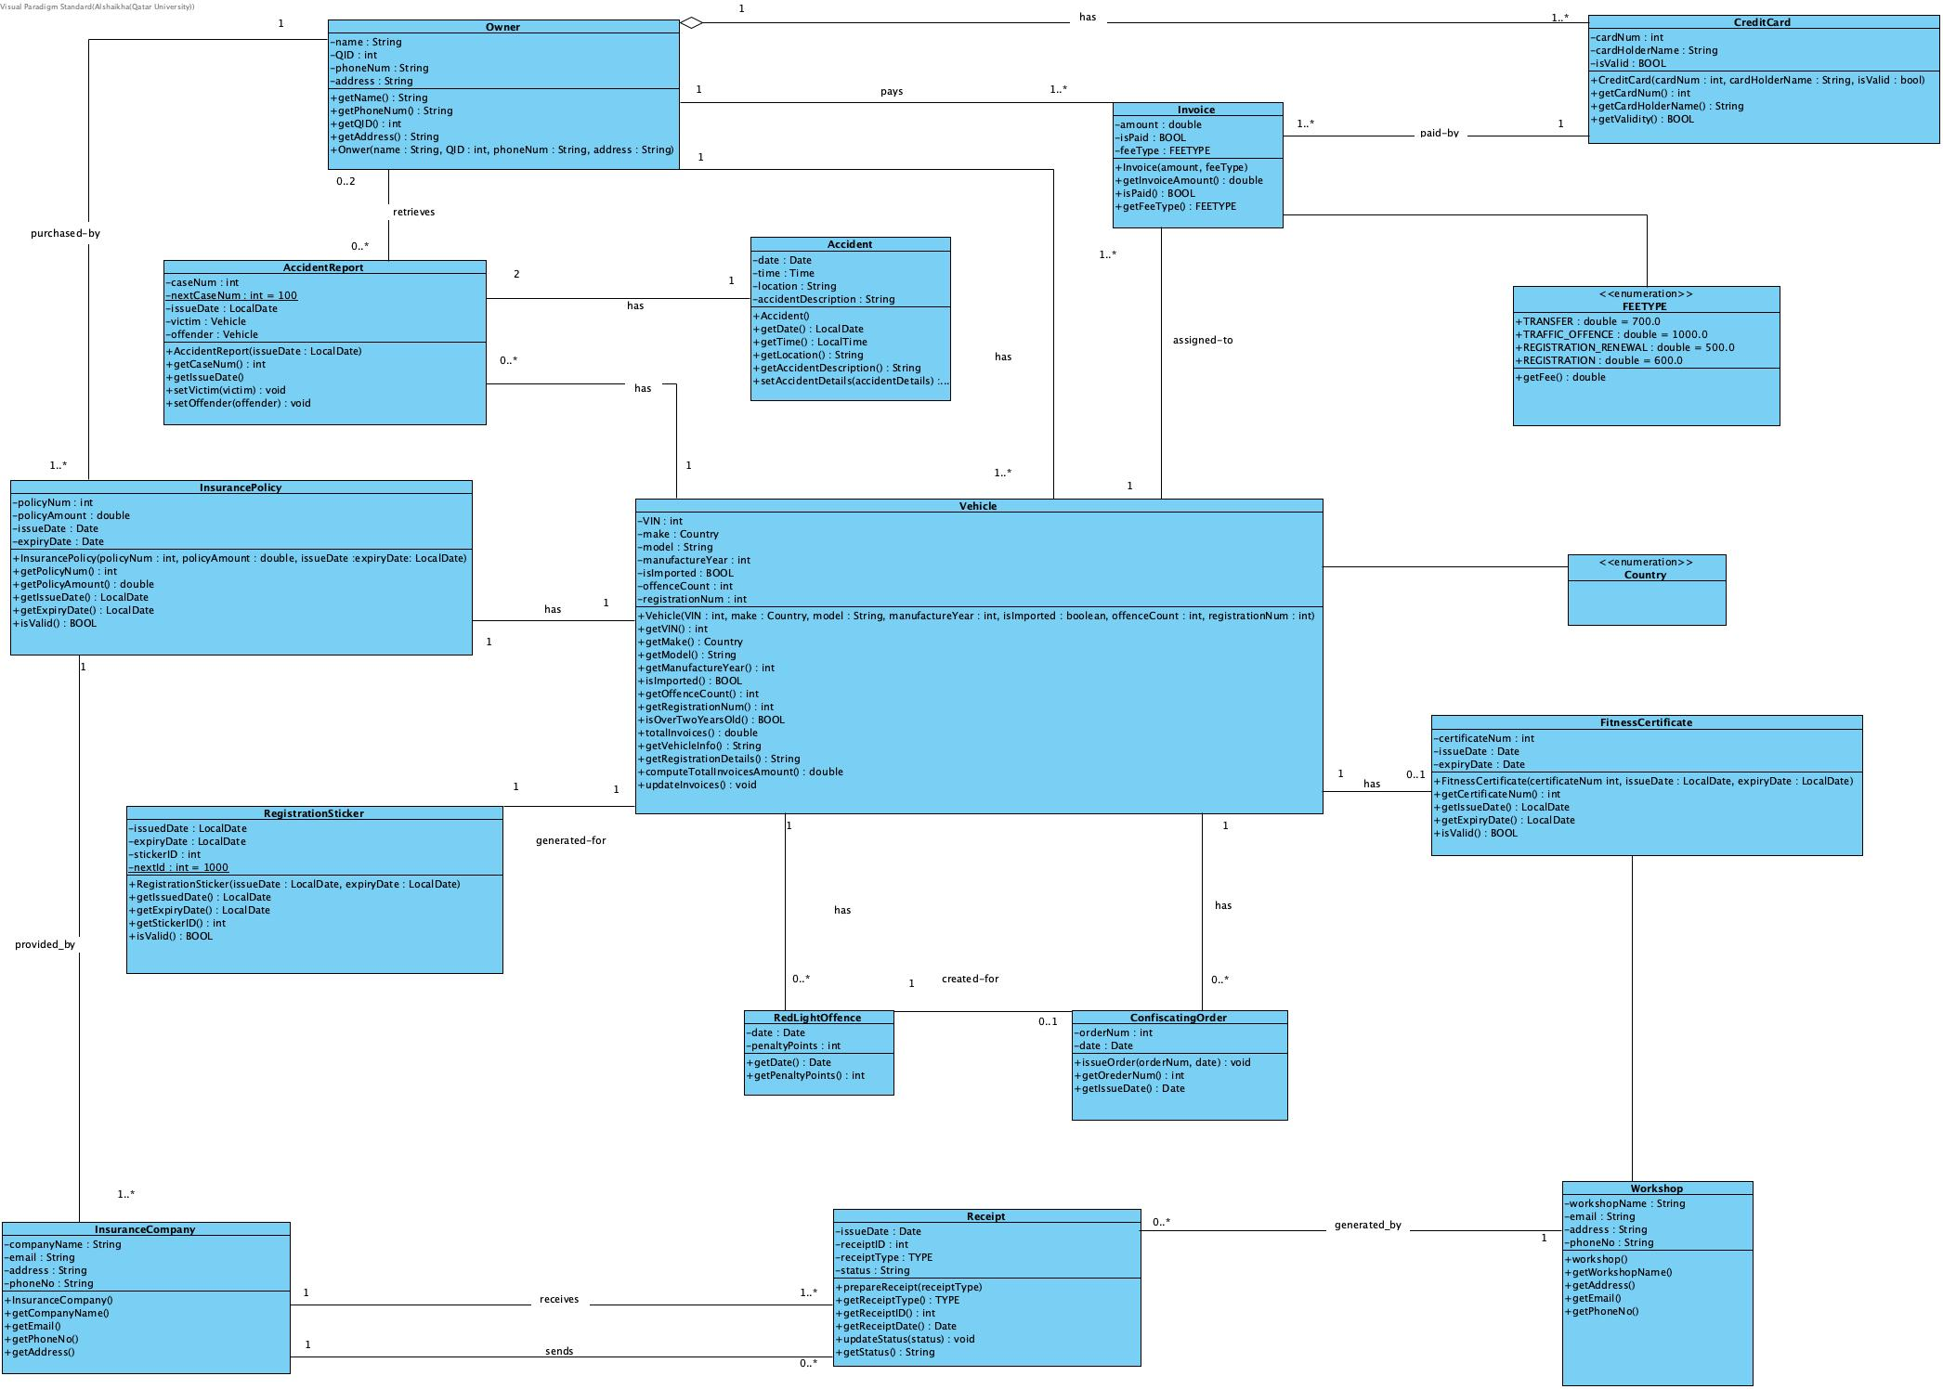

**Task 2**

**Constraints**

**1. Technical Constraints**

**Platform and Software Compatibility:**

1. The system must be developed to work as a plug-in for the existing registration system that operates with the Oracle database.
2. The system must be compatible with existing technology, including Java and C, as most functions were developed using these languages.
3. The system must be portable and run on various devices like mobile phones, tablets, and desktops.

**Scalability:**

1. The current system is designed to handle 10 million vehicles, but it needs to scale to support more than 30 million vehicles in the next 10 years.

**System Integration:**

The iQVR system must integrate with external systems such as:

1. qPay system for payment processing.
2. The vehicle manufacturer’s system for VIN verification.
3. Qatar Trade Service for checking the vehicle’s import records.
4. Insurance companies and authorized workshops for insurance and fitness certificates.

Integration with these systems must be seamless, and the iQVR system should receive acknowledgment receipts from each external system.

**System Modularity and Distribution:**

1. The system could be distributed in the future, with different components running on different machines in different locations.
2. The system components should be loosely coupled and focused to enable future upgrades and modifications without affecting the entire system.

**Database Dependency:**

1. The system must use Oracle for data management, limiting flexibility with other database systems.

**Backup and Availability:**

1. Backup modules must be managed to ensure system availability to users most of the time.

**2. Operational Constraints**

**Staffing:**

1. The traffic police department can only hire 10 new technical staff to manage and support the system.
2. Only one system administrator will manage the entire automated process, which limits the administrative capacity.

**Server Limitations:**

1. The department has a budget for only 20 new servers, which limits the infrastructure expansion possibilities.

**Development Timeframe:**

1. The first version of the system must be completed within three months to avoid penalties for the department, as the system needs to be operational within 12 months.

**Maintenance and Upgrades:**

1. The system should allow modifications and upgrades to some functions without changing the interfaces or affecting other components.

**3. Legal and Regulatory Constraints**

**Data Privacy and Confidentiality:**

1. Vehicle data, ownership details, and core vehicle information are confidential and must not be exposed to general users.
2. These sensitive data elements need to be protected by separating them from high-level user interfaces.

**Compliance with Traffic Laws:**

1. The system must adhere to Qatar’s traffic laws and vehicle registration regulations.
2. Accident reports and fine management must align with existing traffic policies, including red-light offences.

**Authorized Users Only:**

1. Only vehicle owners, insurance companies, authorized workshops, and traffic police have access to specific services, ensuring limited exposure of certain functions.

**Insurance and Fitness Certificate Validation:**

1. Insurance and fitness certificates must be provided by authorized entities and stored in compliance with local regulations.

**4. Performance Constraints**

**System Responsiveness:**

1. The system should handle vehicle registration renewals, ownership transfers, and other services in real time, ensuring low latency and efficient processing.

**Transaction Load Handling:**

1. The system must be able to handle a large number of transactions concurrently as the number of vehicles increases.
2. Payment and billing functions must be efficient, especially when handling traffic fines and invoices.

**5. User Constraints**

**Login and Authentication:**

1. User login functionality (for vehicle owners, insurance companies, and workshops) is assumed to be handled by an external system and is not within the development scope of the iQVR system.

**User Interface Complexity:**

1. The system must be user-friendly for non-technical users like vehicle owners, insurance companies, and workshops, ensuring minimal technical knowledge is required for its use.

**6. Security Constraints**

**Credit Card Security:**

1. Payment transactions, especially involving credit card details, must comply with security standards, including encrypting sensitive information.
2. qPay system must validate the credit card before any transaction is approved.

**Authorization and Access Control:**

1. Only authorized personnel (system administrators, traffic police, and authorized users) should have access to critical system functions like red-light offence reports and vehicle confiscation orders.

**Non-Functional Requirements**

**1. Scalability**

* The system shall currently support 10 million vehicles. And shall be able to scale to support more than 30 million vehicles in the next 10 years.
* The system shall handle the growing number of transactions (e.g., registrations, renewals, penalties).
* The System shall allow horizontal scaling (adding more servers or distributed systems) to meet demand.

**2. Performance**

* The system shall display search results to the user within 0.5 seconds of the query submission, assuming a stable broadband connection.
* The system shall Response for critical user interactions (e.g., registering vehicles, transferring ownership) within 2 seconds.
* The system shall support up to 10,000 concurrent users with minimal degradation in performance.
* The system’s Batch processes (e.g., daily updates, backups) shall not affect online transaction speeds.

**3. Security**

* The system shall protect Vehicle registration details, owner data, and core system data with strong encryption (e.g., AES-256).
* The system shall allow only authorized users (e.g., vehicle owners, workshops, traffic police) to access specific features. Implement multi-factor authentication (MFA) for sensitive functions.
* The system shall separate core data (e.g., vehicle ownership details) from user-facing interfaces to avoid direct exposure.

**4. Availability**

* The system shall be available 98.6% of the time, including during peak hours.
* Downtime within normal working hours shall not exceed 7 seconds in any one day.
* Redundancy and failover mechanisms shall be in place to ensure minimal downtime in case of server failure.
* Regular backups of critical data shall be conducted daily, with an automated restoration process for disaster recovery.

**5. Portability**

* The system shall be accessible across various platforms (e.g., mobile phones, tablets, desktops).
* The interface shall be responsive and adapt to different screen sizes and resolutions.

**6. Interoperability**

* The system shall integrate seamlessly with the external systems mentioned (insurance companies, workshops, vehicle manufacturers, Qatar Trade Service).
* The system shall use standard communication protocols (e.g., HTTPS, RESTful APIs) to ensure compatibility with third-party services.
* The system shall work smoothly with qPay for payment processing without any noticeable delay.

**7. Maintainability**

* The system shall be modular, with clearly defined components for each function (registration, payments, penalties) to allow easy upgrades and modifications.
* The codebase shall follow clean coding practices, enabling future developers to modify or add features without impacting the existing system.

**8. Reliability**

* The system shall be fault-tolerant, meaning it should continue operating smoothly even when individual components fail.
* Any errors during critical operations (e.g., payments, transfers) shall be handled gracefully, with clear error messages and automatic retries where appropriate.

**9. Data Integrity**

* The system shall ensure that all vehicle registration data and transaction details are accurate, with no loss or corruption of data during updates or transfers.
* Strong validation checks shall be in place to prevent invalid or duplicate entries for VINs, QIDs, and other essential data.

**10. Compliance**

* The system shall comply with Qatar's data protection regulations regarding the handling of personal data (e.g., owner names, QIDs).
* The system shall consider Compliance with international standards for vehicle registration systems.

**11. User Experience (Usability)**

* The system shall be intuitive and easy to navigate, with clear instructions for vehicle owners, workshops, and insurance companies.
* Error handling shall be user-friendly, providing detailed information on how to resolve any issues (e.g., unpaid fines, missing documents).
* The system shall offer multi-language support, especially Arabic and English, to cater to all users in Qatar.

**12. Modularity and Extensibility**

* The system shall be designed to allow new functionalities to be added in the future without major overhauls.
* Each component shall operate independently, enabling developers to modify or remove specific sections (e.g., penalties, registration) without affecting the entire system.

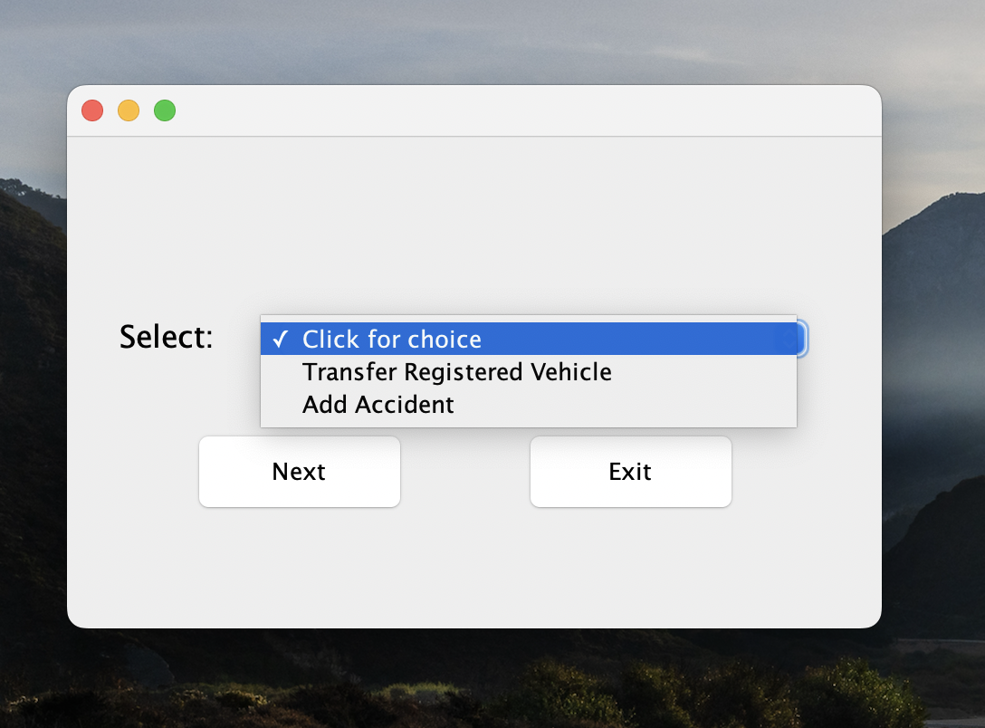**Task 3**

Our main menu contains two options (each represent the use cases in the appendix).

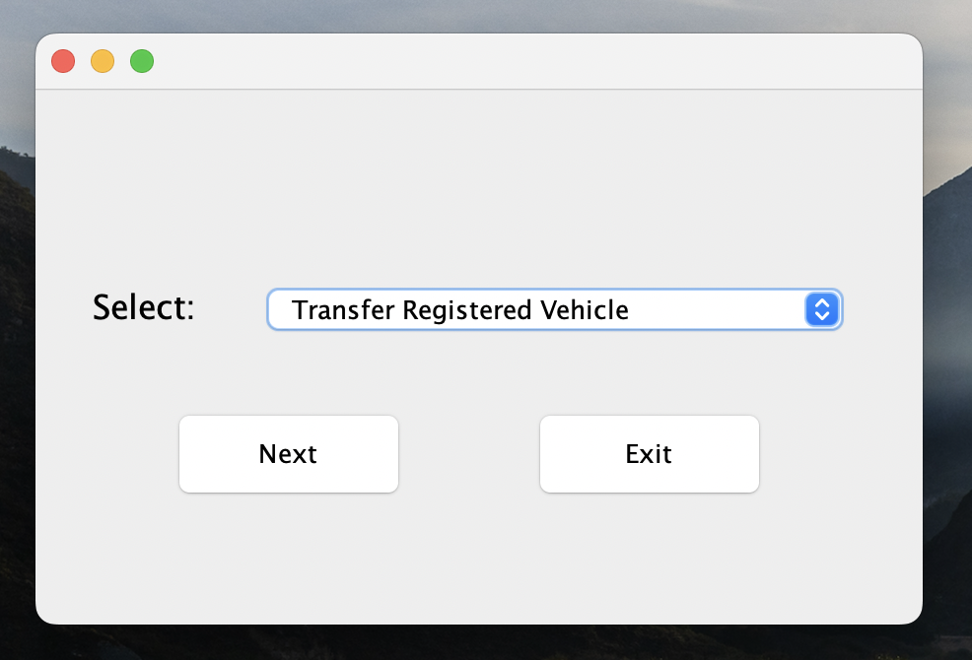

First option represents transfer registered vehicle use case.

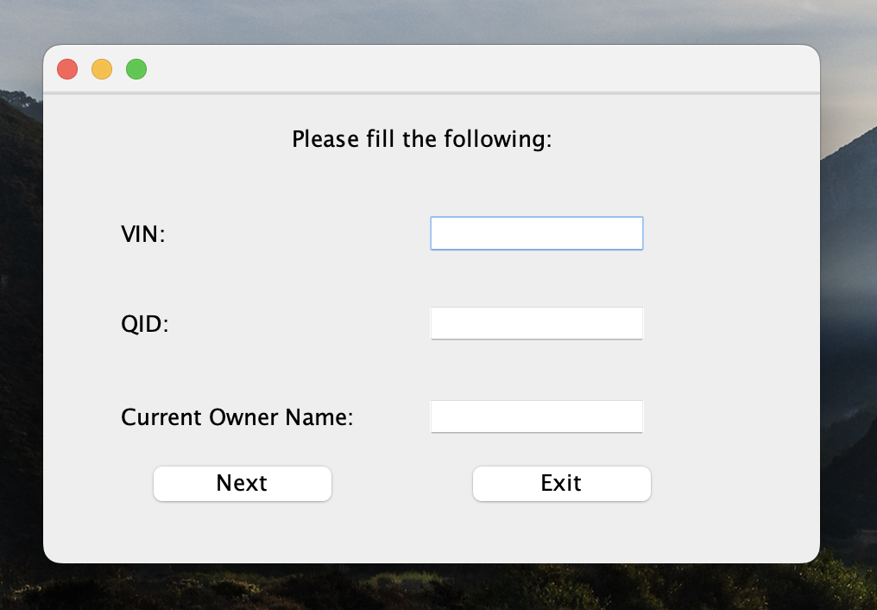

After clicking on next, a new page will appear for the current owner of the vehicle to enter his/her information (which is saved in our database)

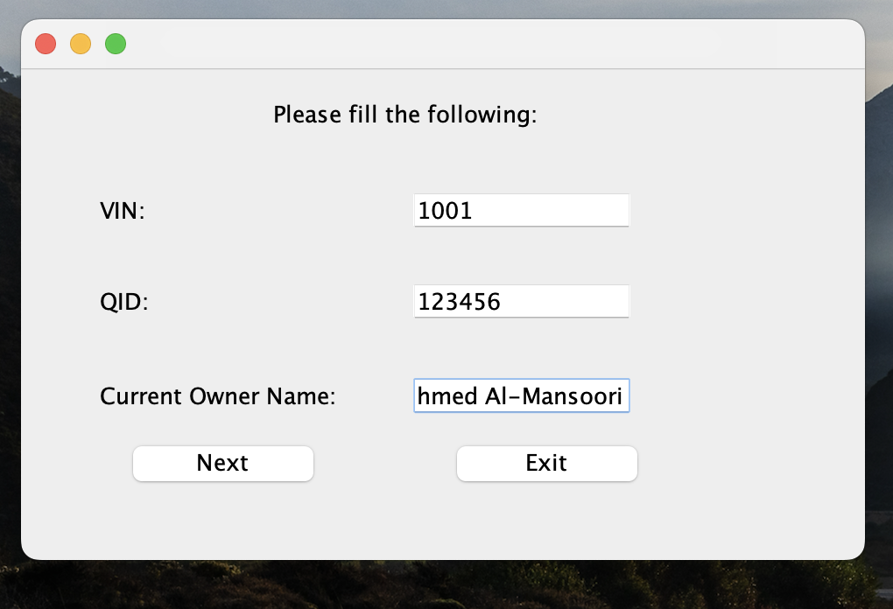

**Validations for the current owner details**

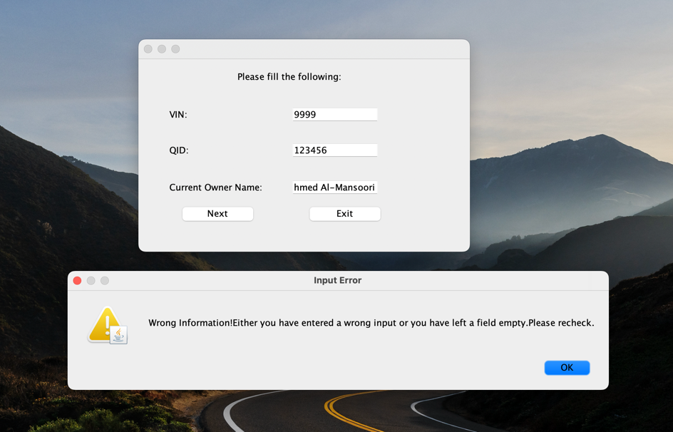

In case the current owner enters a wrong VIN

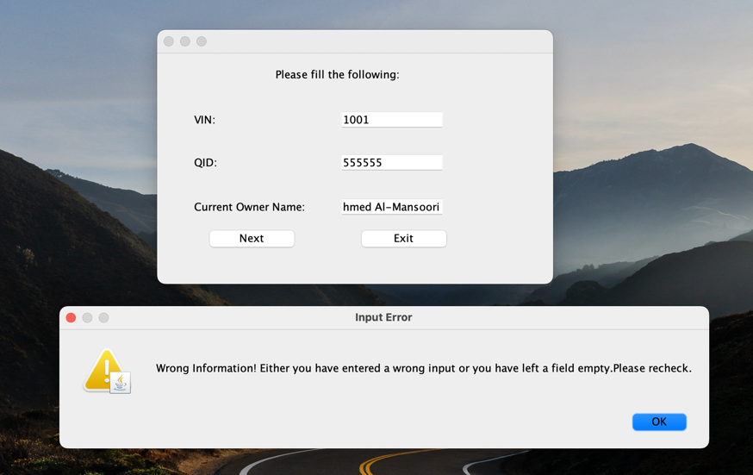

In case the current owner enters a wrong QID

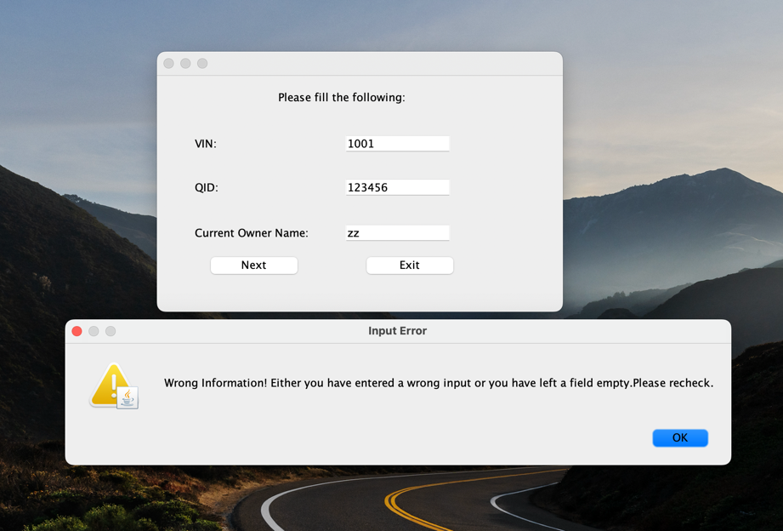In case the current owner enters a wrong name

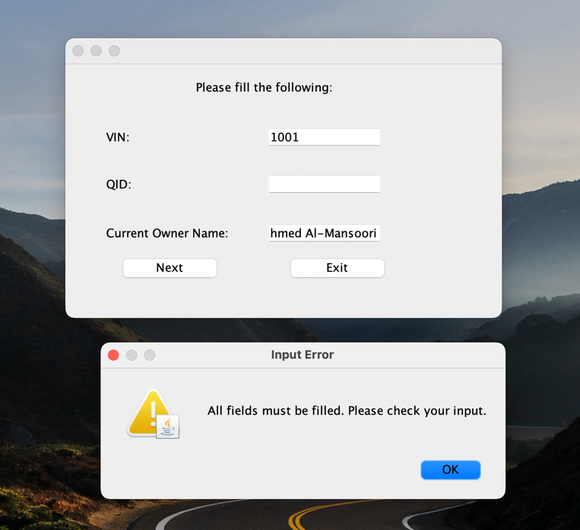**Validations for the current owner details**

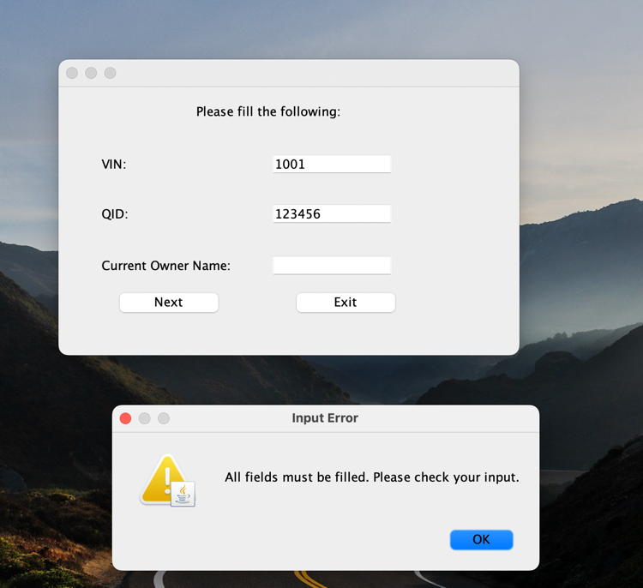

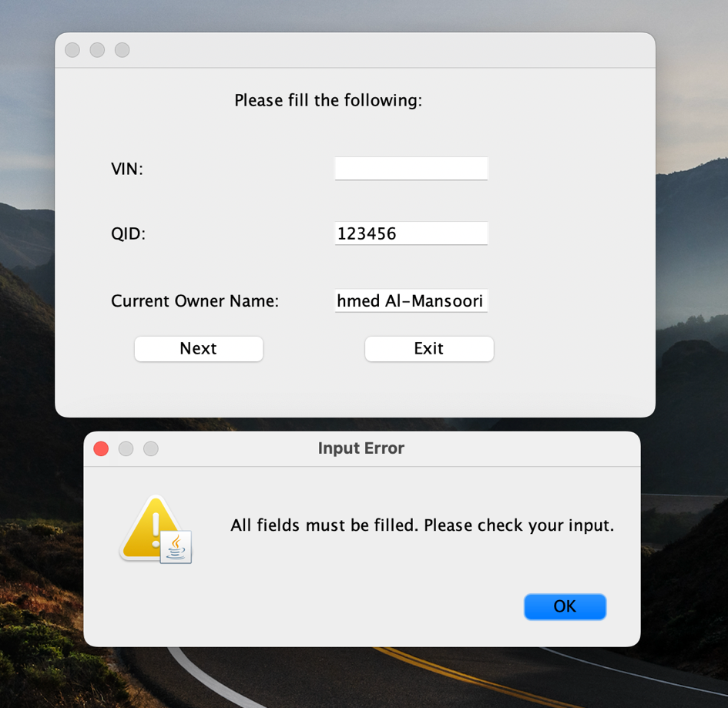

In case the current owner leaves an empty field

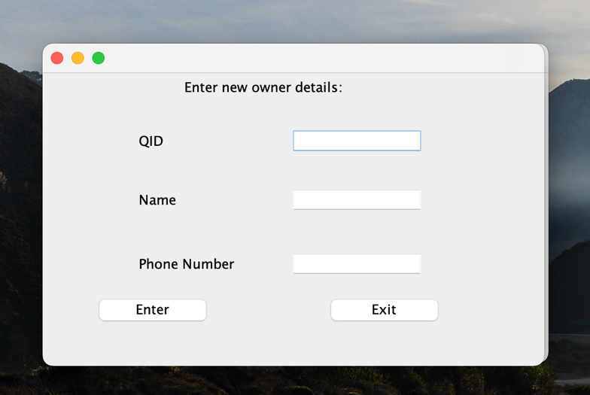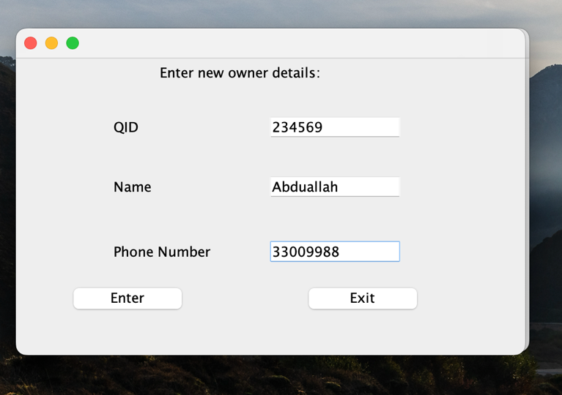

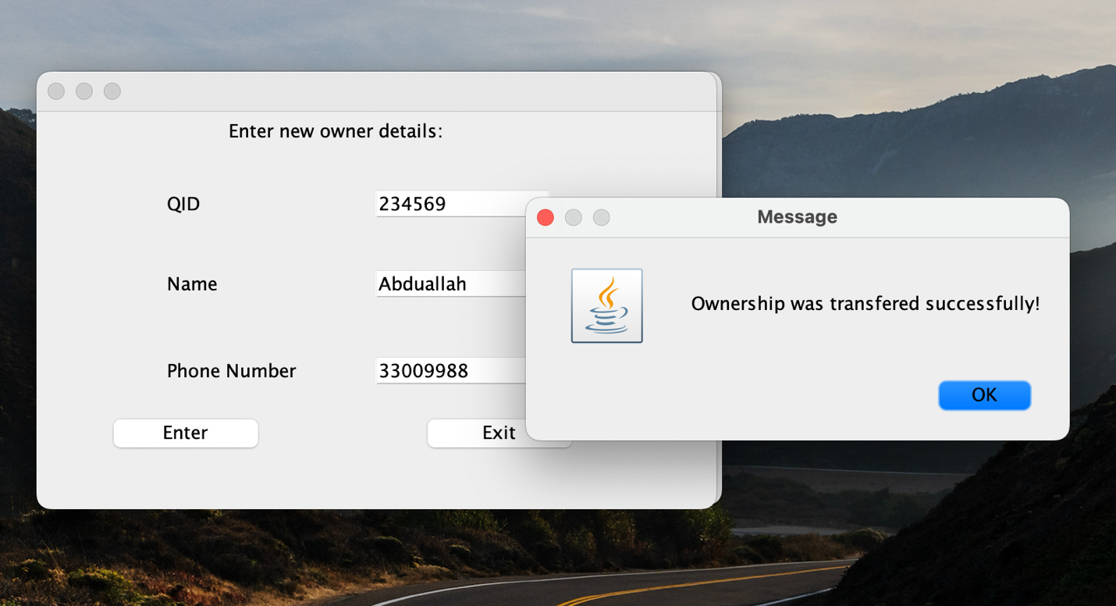

**In case the current owner enters his/her right details,** another page will appear to enter the new owner’s details. And a message will appear to confirm the success of the process.

**Validations for the new owner details**

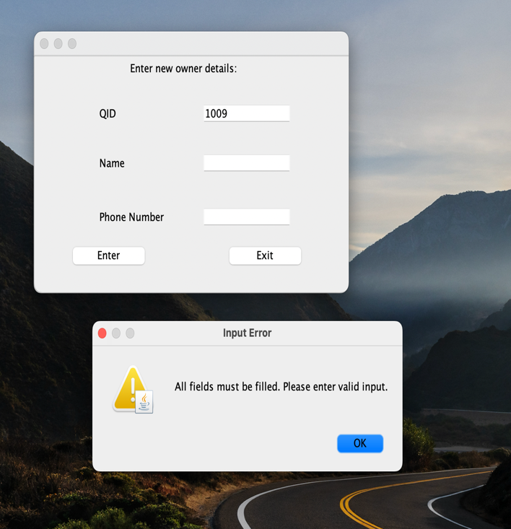

In case some fields were left empty:

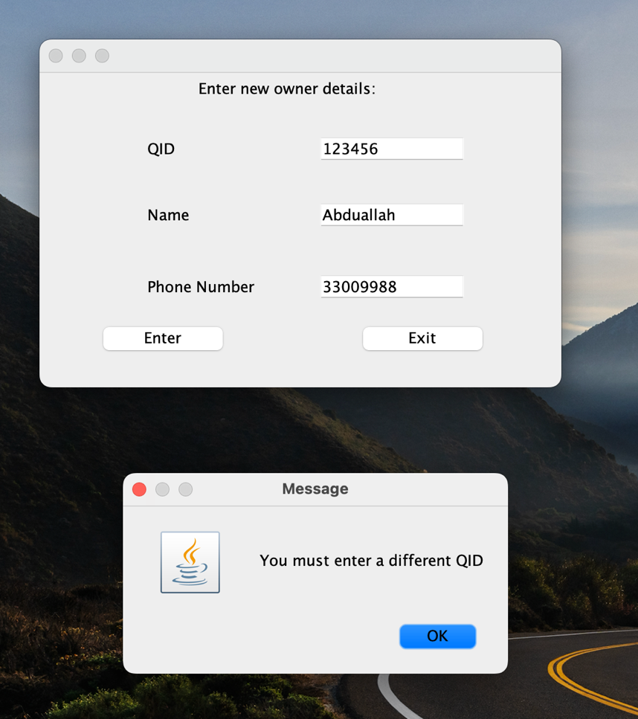

In case the current owner enters his/her QID for the new owner

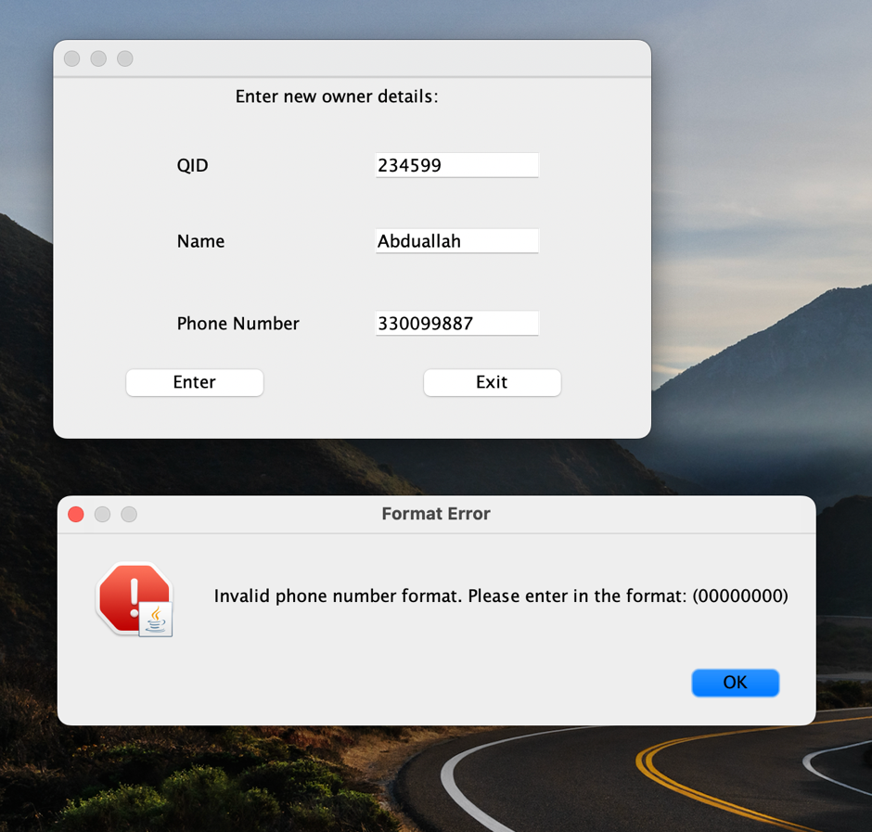

In case the current owner enters a wrong format of the phone number of the new owner (only 8 digits are allowed)

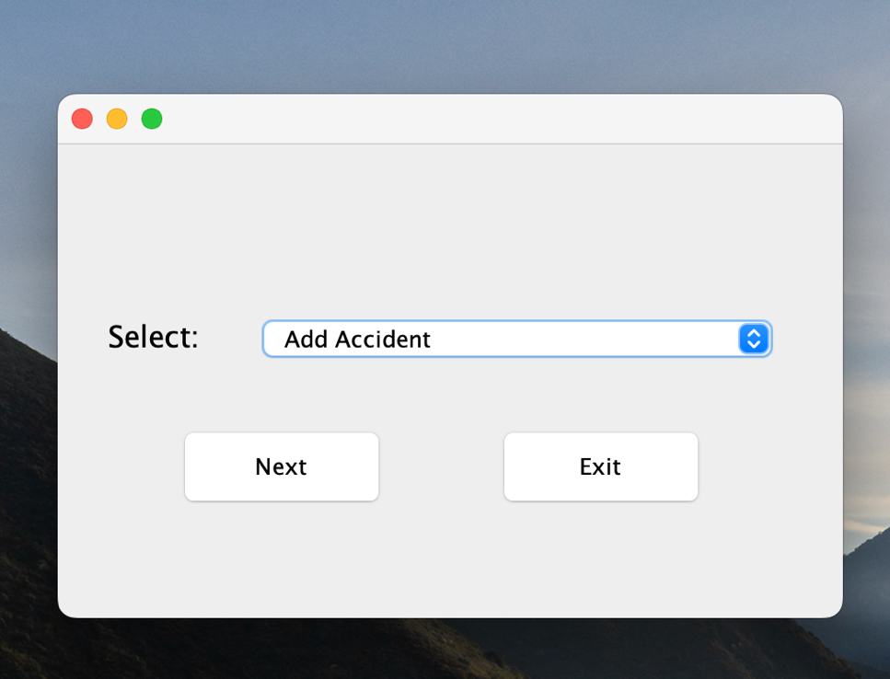

**Option 2 for the second use case – Manage Accident**

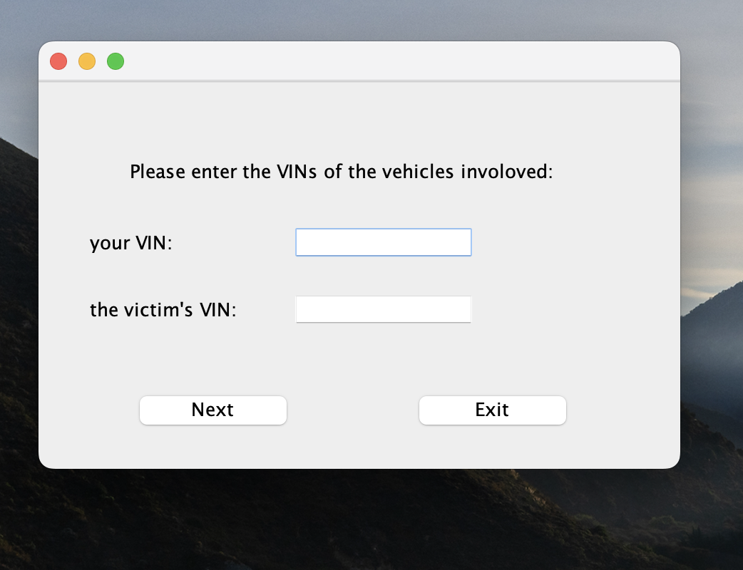

After clicking on next, a new page will appear for the offender to enter his/her VIN and the victim’s VIN

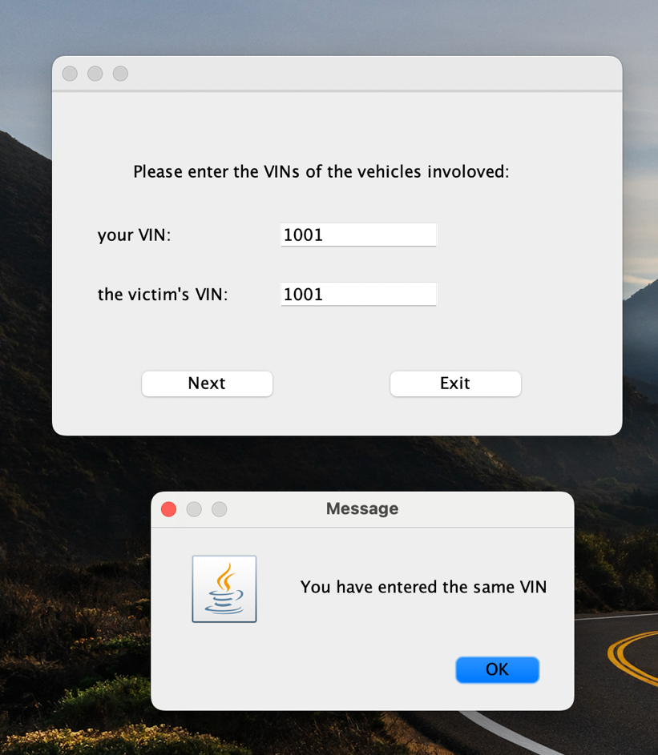**Validations**

if the offender owner enters the same VIN for both fields, an error message will appear

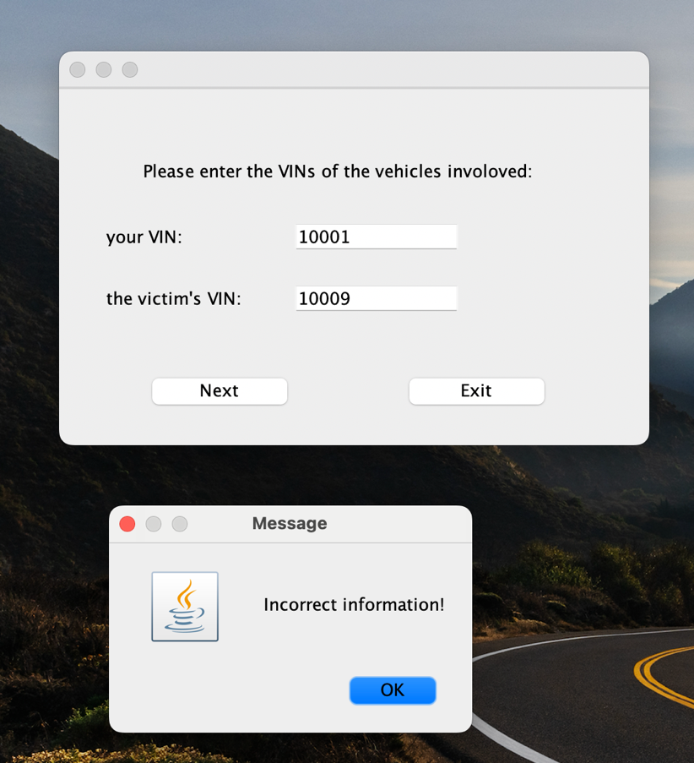

If the offender enters wrong VIN for either him or the victim an error message will display.

(the VINs in the example do not exist in our system database)

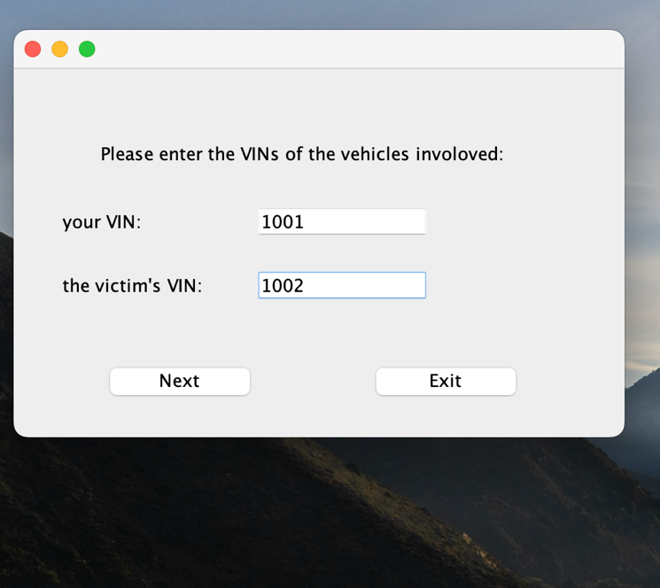

In case the offender enters the correct information, a new page will display for entering the accident details.

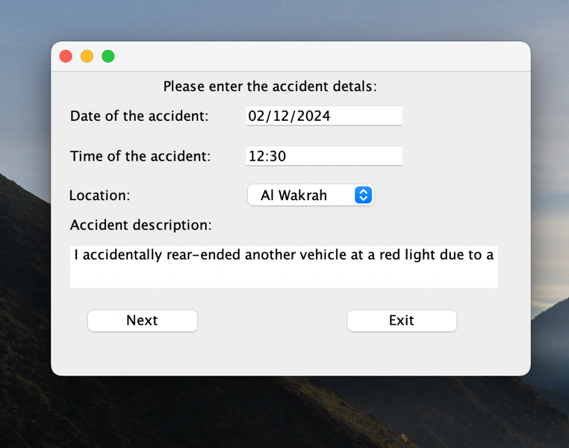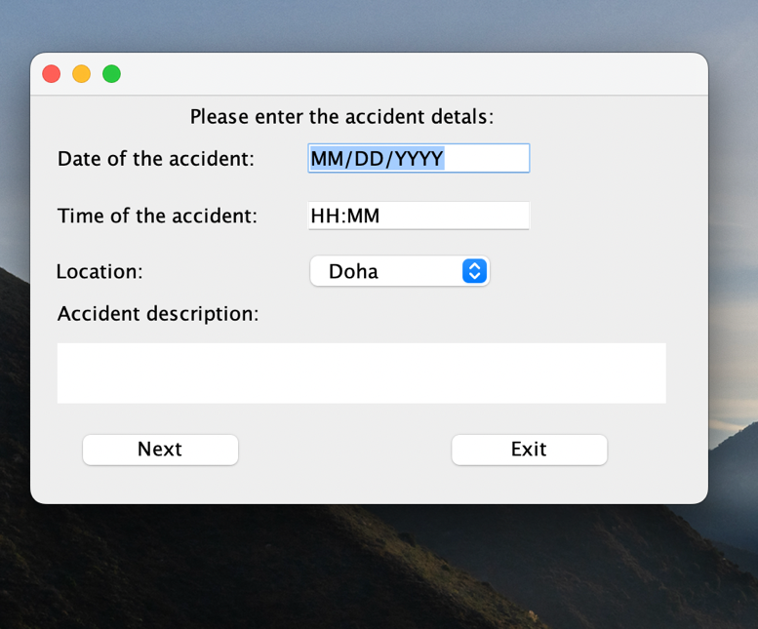

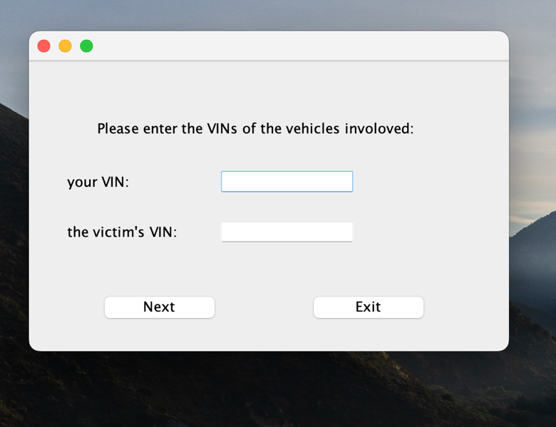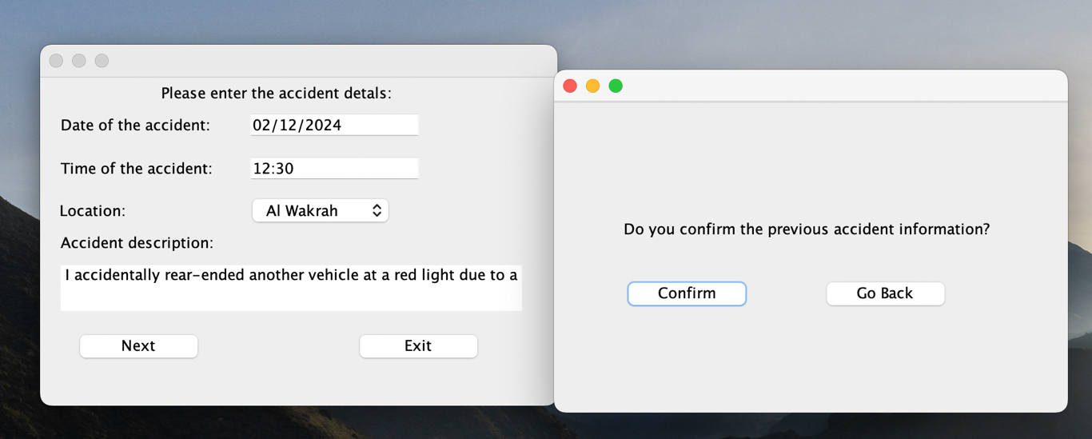

after entering the details, the system will ask the offender to confirm the accident details, or they can go back to enter the VINs.

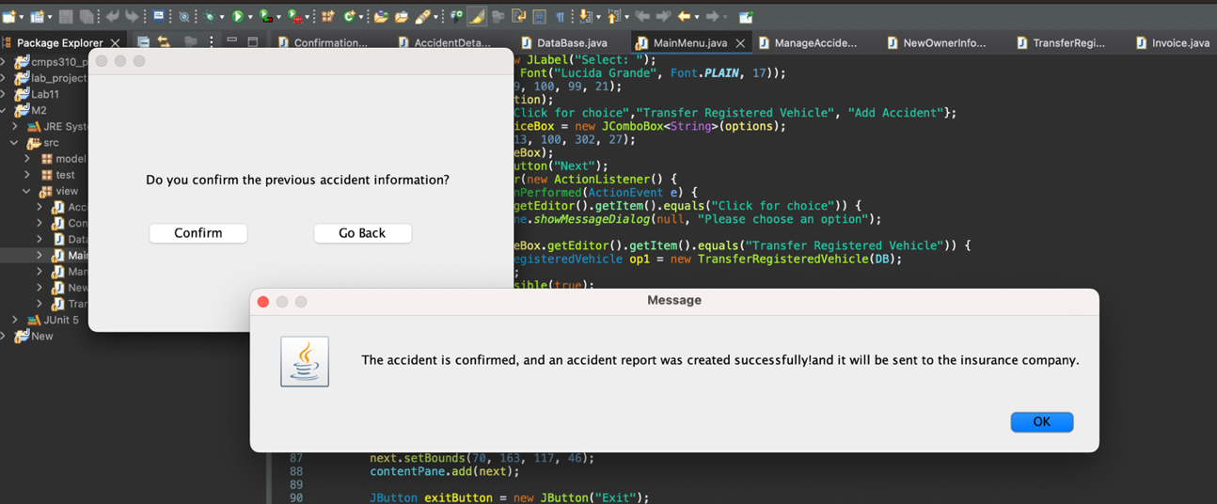

In case the offender confirms the information, a message will display

**Task 4**

For the testing, we have chosen 4 classes to test (Owner, Vehicle, Accident, and AccidentReport)

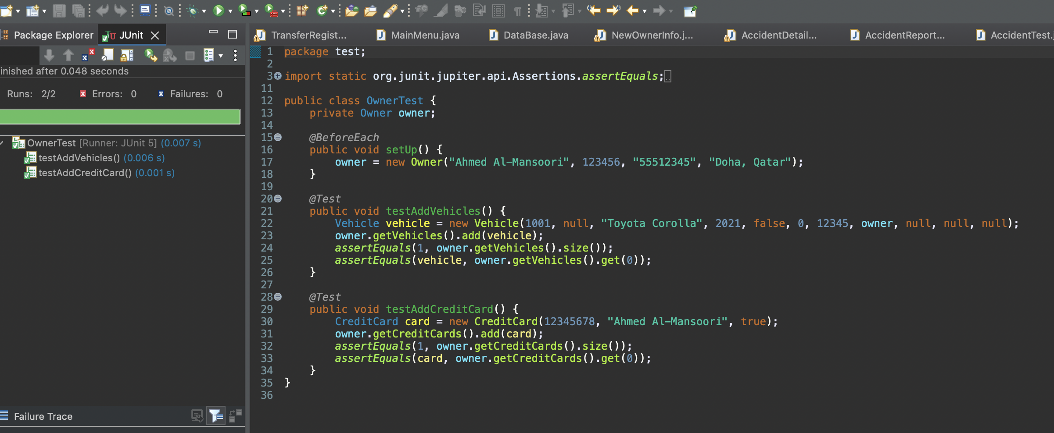**OwnerTest**

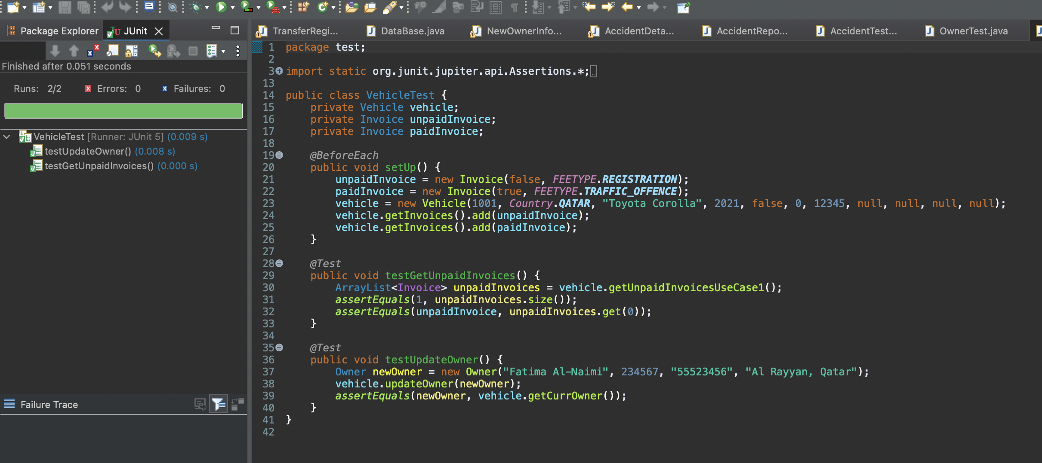**VehicleTest**

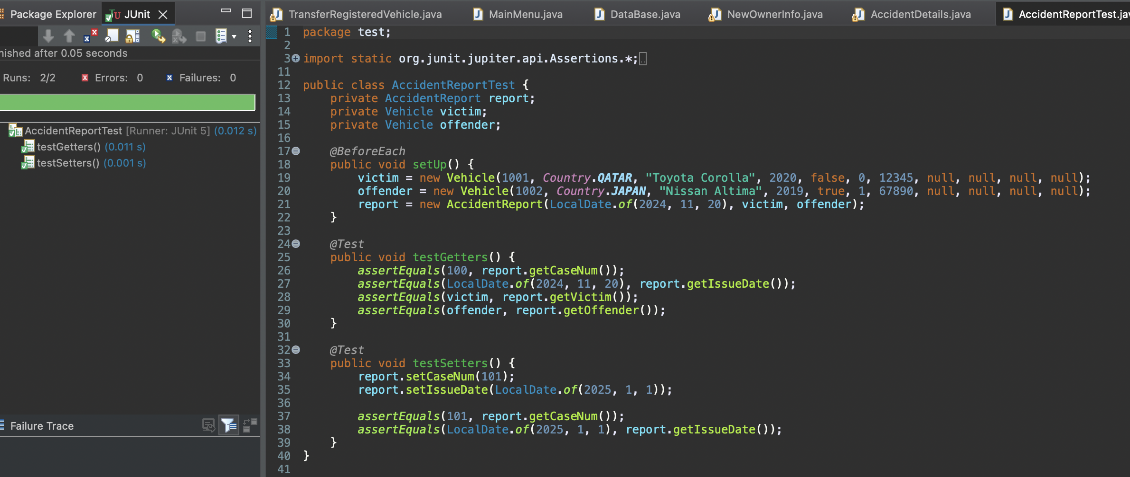**AccidentReportTest**

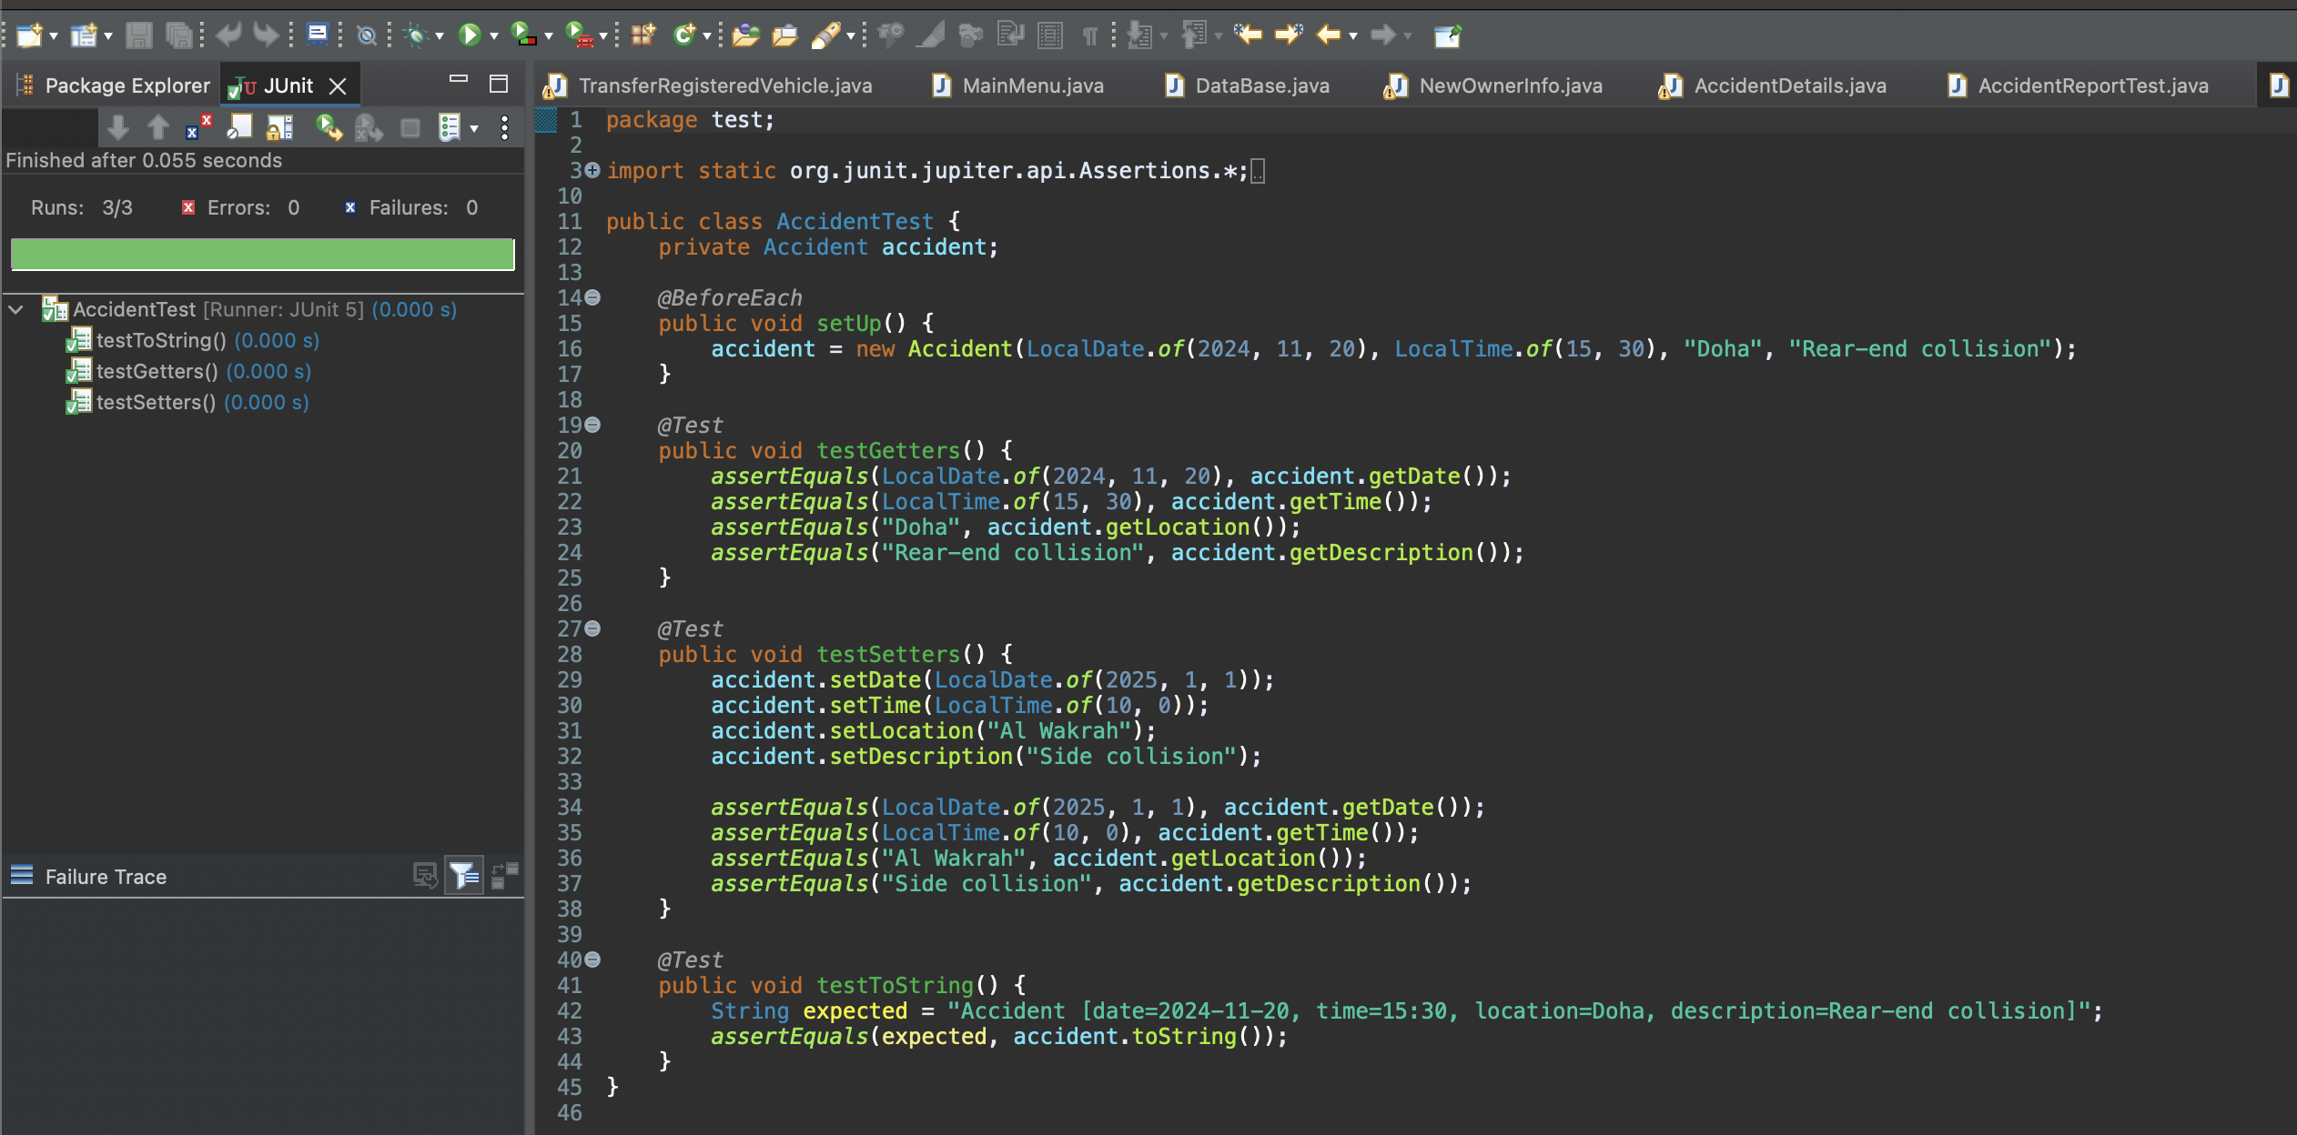**AccidentTest**

**Task 5**

We chose to test two NFRs which are related to **performance** and **Usability:**

1. **Performance**:
   1. The system shall display response results to the user within less than 0.05 seconds of the query submission, assuming a stable broadband connection.

*Test Conducted*

We measured the response time of key system operations during implementation. This was done using code execution timestamps for critical workflows, such as:

- Transferring vehicle ownership.

- Managing accidents.

- Each operation's start and end times were recorded to calculate the total response time.

Results:

- Average Response Time:

- Transferring vehicle ownership: 0.047235083 seconds.

- Managing accidents: 0.046753584 seconds.

- All measured response times were under the required 0.05-second threshold.

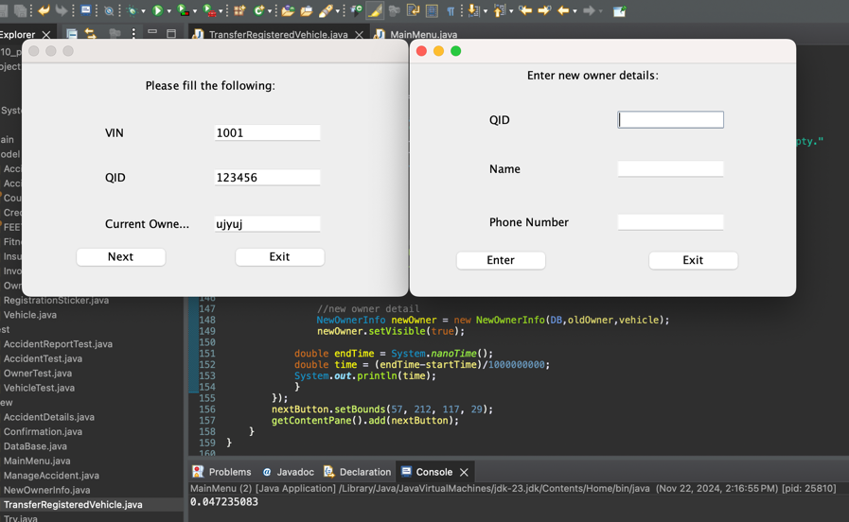

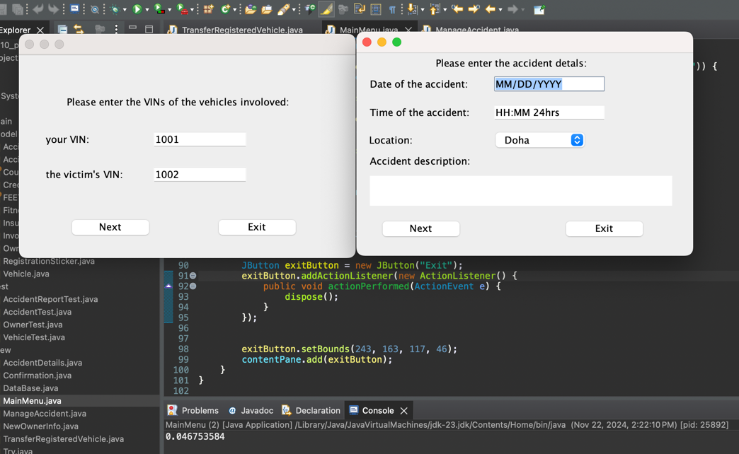



1. **Usability:**
   1. The system shall be intuitive and easy to navigate, with clear instructions for vehicle owners, workshops, and insurance companies.
   2. Error handling shall be user-friendly, providing detailed information on how to resolve issues (e.g., unpaid fines, missing documents).

*Test Conducted*

We conducted a usability survey with 10 participants, who completed tasks such as transferring vehicle ownership and reporting accidents. The survey questions evaluated:

**Survey Results**

1. Ease of Navigation  
   *"How easy was it to navigate through the system to find the required features (e.g., transferring vehicle ownership, reporting an accident)?"*
   * 64.3% rated it as "Very Easy."
   * 14.3% rated it as "Easy."
   * 14.3% were "Neutral."
   * 7.1% rated it as "Very Difficult."

Most users (78.6%) found the system intuitive to navigate. However, improvements could be made to assist the 7.1% who found navigation challenging.

1. Sufficient Guidance  
   *"Did the system provide sufficient guidance to help you complete the tasks without confusion?"*
   * 57.1% found the guidance "Very Helpful."
   * 21.4% rated it as "Helpful."
   * 14.3% were "Neutral."
   * 7.1% rated it as "Slightly Helpful."

The system effectively provides guidance, with 78.5% of users finding it helpful or very helpful.

1. Error Handling  
   *"Did the system handle invalid inputs or errors (e.g., unpaid fines, missing documents) in a helpful and user-friendly way?"*
   * 57.1% rated it as "Very Helpful."
   * 28.6% rated it as "Helpful."
   * 7.1% rated it as "Slightly Helpful."
   * 7.1% were "Neutral."

The system's error handling is user-friendly and meets expectations, with the majority of users finding it helpful or very helpful.

1. Error Message Detail  
   *"Were the error messages detailed enough to help you resolve issues effectively?"*
   * 50% rated messages as "Very Detailed."
   * 35.7% rated them as "Good."
   * 14.3% were "Neutral."

Most users (85.7%) found the error messages clear and informative, addressing issues effectively.

1. System Responsiveness  
   *"Did the system respond promptly to your inputs and commands?"*
   * 64.3% rated it "Very Fast."
   * 21.4% rated it "Fast."
   * 7.1% rated it "Very Slow."
   * 7.1% were "Neutral."

Over 85% of participants found the system responsive, demonstrating its ability to meet performance and usability expectations.

1. Overall Usability and Design  
   *"How satisfied are you with the overall usability and design of the iQVR system?"*
   * 71.4% rated it as "Very Satisfied."
   * 14.3% rated it as "Satisfied."
   * 14.3% were "Neutral."

The majority of users (85.7%) were satisfied with the system's overall usability and design, validating its user-centric development approach.

The results confirm that the system meets the usability requirements, with high ratings for navigation ease, sufficient guidance, and overall satisfaction. Minor areas of improvement include enhancing clarity for the small percentage of users who found navigation or guidance slightly challenging.

The survey link:

<https://docs.google.com/forms/d/e/1FAIpQLSf8TYzyiALaJzlCMjaqsTmZcqKiBNUn4QR3LRW0g156VyiFdg/viewform>